

|  |
| --- |
| Binh Duc Nguyen |
| Researching and AI Testing Strategies For Video Management System. |
|  |
|  |

|  |
| --- |
| Information and Communication  2023 |
|  |

VAASAN AMMATTIKORKEAKOULU

UNIVERSITY OF APPLIED SCIENCES

Information Technology

**ABSTRACT**

Author Binh Nguyen

Title Researching and AI API Testing for Video Management

System

Year 2023

Language English

Pages 63 + 3 Appendices

Name of Supervisor Kenneth Norrgård

Embark on an insightful exploration of testing strategies for ITD Group’s Smart Video Management System within the context of this thesis. This study delves into the realm where cutting-edge technology converges with boundless information. The Video Management System is simulated employing with Python, facilitating a comprehensive understanding of its intricate working.

This thesis also moves us with the transition from manual testing API into advanced methods like unit testing and real cam Testing. Unveiling the features of AI APIs, system bugs, script tests. Moreover, the thesis will analyze similar video management system like Milestone, Kerberos.io for the valuable insights.

With all the above activities, this study illuminates a pathway to be a responsible Software Engineer within the realm of Video Management System.

Keywords Video Management System (VMS), Python, Open Source, Docker, Kubernetes, unit testing, automation, AI APIs, system bugs, script tests, Milestone.

**CONTENTS**

Tiivistelmä

ABSTRACT

1 IntroDuction 7

This academic thesis is compiled with data information literacy interspersed with practice, if you are curious about a similar field, please patiently follow the steps from the top down. 7

1.1 Background of ITD Group’s Smart Video Management System 7

1.2 ITD’s AI description API document (IMPORTANT) 7

2 Literature review 8

2.1 Overview of video management systems with AI capabilities 8

2.2 Best practices for testing and quality assurance in Video Management Systems. 10

2.3 Description of the software and hardware used in the thesis. 12

2.4 Overview of similar Video Management System 13

2.4.1 VMS MileStone: Milesight VMS is a video management system designed for use in a variety of environments, from small businesses to large scale enterprises. 13

2.5 Implementation Phase – Theory and Empirical Section of the Study/ Project 13

2.6 Reporting Phase – Analysis and Publication of the Results 13

3 INSTRUCTIONS FOR WRITING 16

3.1 Appearance 16

3.2 Use of Styles and Contents Page 17

3.3 Referencing and the List of References 17

3.4 Examples of List of References 20

3.4.1 Printed Books 21

3.4.2 Printed Articles (e.g. in Periodicals or Compilations) 21

2.4.3 Electronic Publications (e.g. Online Articles, Web Pages and Sites, DVDs and CDs) 21

2.4.4 Interviews 22

2.4.5 Conference Presentations 23

2.4.6 Sources that Start with an Official Abbreviation (e.g. Laws) 23

2.4.7 Other Sources (e.g. Minutes, User Instructions and Statistics) 23

2.4.8 E-mail 23

2.4.9 Standards 23

2.4.10 Patents 23

4 APPEARANCE 24

5 ENDING PHASE – ASSESSMENT OF THE THESIS AND MATURITY TEST 26

5.1 The Presentation Time of the Thesis 26

5.2 Maturity Test, Bachelor’s Degree 27

5.3 The Maturity Test for the Master’s Thesis is a Thesis Press Release 29

5.4 Thesis Assessment, Bachelor’s Thesis 33

references 36

APPENDICES

**LIST OF FIGURES AND TABLES**

**Figure 1.** Style menu window. p. 15

**Table 1.** Responsibilities related to thesis. p.9

**Table 2.** Examples of contents of the thesis. p.12

**LIST OF APPENDICES**

**APPENDIX 1.** Thesis passport

**APPENDIX 2:** Appendices

**APPENDIX 3.** Thesis assessment criteria

IntroDuction

## This academic thesis is compiled with data information literacy interspersed with practice, if you are curious about a similar field, please patiently follow the steps from the top down.

## Background of ITD Group’s Smart Video Management System

ITD Group is at the fore of innovative efforts as Vietnam approaches a crucial turning point in its digital transformation in 2023. ITD group has worked on many initiatives as part of its commitment to digital transformation that have transformed business practices in Vietnam and elsewhere, including the creation of a smart camera management system. This system holds great potential in various domains such as time attendance management, building security, road traffic system, monitoring, and highways, offering highly efficient solutions for this area.

The comprehensive nature of the Video Management System project is extensive, as it is built using a microservice architecture. Currently, during the writing of this thesis, the project is still in progress and involves several distinct scopes, including the backend, backend API, AI training model (YOLO v8 currently), API of AI, and various frontend modules for administrator… However, this thesis specifically focuses on in-depth testing of AI APIs for Face recognition, Person detection, and script test for end user of object tracking. Additionally, it delves into VMS research, providing valuable references for the development of ITD Group’s product.

## ITD’s AI description API document (IMPORTANT)

First and foremost, it is necessary to check out the [link here](https://www.notion.so/API-Document-Description-919d28852b3a42ddb4abd0a16573802e?pvs=4) for the AI API Documentation in English version (Which I had honor to be a part of editor).

# Literature review

In this chapter, we explore the World of AI-powered camera systems. We will see how they are used in managing videos, how they’re tested to ensure they work well, and what tools we are using for this study.

To begin, we will look at video management systems that use AI. Then, we will learn about the testing methods to ensure these systems are reliable as well as the software and hardware we are using.

Lastly, we will peek at similar Video Management Systems like Milestone or Kerberos.io. This chapter sets the stage for our deeper dive into how AI is impacting video management.

This chapter lays the foundation for understanding AI camera systems and their impact on Video management.

## Overview of video management systems with AI capabilities

Video management system (VMS) are software platforms designed to manage, record and analyse video footage from surveillance cameras. The integration of Artificial Intelligence (AI) within VMS has significantly transformed the landscape of video surveillance by enabling advanced functionalities that go beyond traditional video management. AI-powered VMS leverages machine learning algorithms to process and understand video data, offering enhanced security, operational efficiency, and actionable insights.

* **Concept 1: AI-enhanced Video Analysis**

Real-time video analysis, including object detection, tracking, and recognition, is made possible by AI using VMS. With the use of these abilities, VMS is able to recognise and classify objects, people, vehicles, and events inside video streams. For instance, AI can watch suspicious conduct, monitor crowd density, detect unauthorised access, and more.

Image:

* **Concept 2: Predictive Analytics and Anomaly Detection**

A VMS with AI integration can predict security breaches by looking at past data and seeing trends. Alerts can be sent out when anomaly detection algorithms spot odd behaviour or events. By addressing possible dangers prior to them becoming more serious, this proactive strategy improves security.

Image:

* **Concept 3: Automated Alerts and Notifications**

Based on established parameters, AI-powered VMS can automatically produce alerts and notifications. This function guarantees quick response to serious occurrences. Security professionals can receive alerts via email or mobile apps, allowing them to take prompt action.

Image: Screenshot of a mobile app notification alerting the user to a security event detected by an AI-enhanced VMS.

* **Concept 4: Face Recognition and Biometric Analysis**

Identification and verification of people are made possible by the integration of facial recognition technology into VMS. This helps with visitor management, access control, and strengthening security procedures.

Image: This surveillance screen example illustrates the facial recognition capabilities of an AI-integrated VMS by labelling observed faces.

* **Concept 5: Data-driven insights for Decision Making**

AI-driven VMS can extract useful information from video footage to support decision-making. The layout of stores and marketing tactics, for instance, can be improved by studying client mobility patterns in retail settings.

Image: A graphic illustrating how data-driven insights from an AI-powered VMS help with strategic choice-making in a retail setting.

## Best practices for testing and quality assurance in Video Management Systems.

To ensure the dependability and effectiveness of video management systems (VMS) with AI capabilities, stringent testing and quality assurance practices are required. Thorough testing ensures that the system works properly, delivering accurate insights and secure monitoring. This section goes into the important best practices used in AI-infused VMS testing and quality assurance.

* **Concept 1: Understanding the project documentation**

Understanding the project documentation provides a solid basis. Understanding the system's architecture, technical specs, and expected functionality are all part of this. Clear project documentation establishes the context required for effective testing and quality assurance initiatives.

As an AI Test engineer, at some company this is also our responsibility to become one of the editors for those project documentations.

* **Concept 2: Understanding the project**

As a swimming class, we need to know firstly the survive way in our working environment. Let’s take a deep dive into how the system work, how to fetch camera from its IP address, RTSP (Real Time Streaming Protocol), how to connect it with our company API, how to connect the AI System Camera into our personal machine (Laptop, PC), how to draw on it for testing the AI by using OpenCV library, …

If you are a beginner, do not hesitate to bother your boss or senior about those doubts, this concept is important. Just think that you need to clarify what is having and what is not having in your company’s project to enhance those functionalities or make some more technical debt reports to your team.

* **Concept 3: Unit Testing and Automation Testing**

To ensure that the backend of AI VMS functions work well, it is vital to ensure that the AI API functions as expected. During the development process, we could employ a variety of technical tools, such as Postman and pytest. If there is a system bug, AI testing engineers must be responsible for providing feedback to both the AI team and the IT team as soon as possible. In other words, as AI testing engineers, we should serve as a link between our company's AI and IT departments.

Automation testing further streamlines this process by automating repetitive test script being executed using testing tools (E.g., Selenium, pytest, unittest, nose2, tox, …)

* **Concept 4: Comprehensive Testing Framework**

An effective testing framework encompasses functional, performance, and security testing.

Individual aspects such as object detection and alert generating are evaluated during functional testing. System reaction times are measured during performance testing under changing loads, assuring responsiveness even during peak usage. Security testing detects flaws that could be exploited.

* **Concept 5: Chaos Testing**

The process of deliberately putting a system to stressful and unexpected conditions is known as chaos testing. This is critical for robustness since it checks the system's resilience, fault tolerance, and capacity to recover gracefully from faults.

* **Concept 6: User Acceptance Testing (UAT)**

End-users evaluate the system's usability and functioning during user acceptance testing. Real-world user feedback assists in finding areas for improvement and aligning the system with realistic requirements.

## Description of the software and hardware used in the thesis.

This section provides an overview of the software and hardware components used in the thesis project's execution.

* **Software Utilized:**

**Python:** Python, a versatile programming language, acts as the foundation for the AI-powered video management system's development. Python's numerous libraries and frameworks enable rapid data handling and AI algorithm integration.

**OpenCV:** OpenCV (Open Source Computer Vision Library) is a critical tool for image and video analysis. Its capabilities are used within the AI-infused video management system to process video streams, detect objects, and perform other analysis.

**Pytest:** To automate testing operations, Pytest, a popular testing framework, is used. Its simplicity and extensibility simplify the validation of numerous system functionalities.

**Postman:** Postman, a popular API testing tool, assists in testing the AI API's functioning. Its user-friendly UI makes it easier to validate API endpoints and answers.

**Github:** The collaborative platform GitHub is essential for version control and project management. It ensures team members' smooth communication, version tracking, and the availability of the codebase.

**Yolov3:** A pre-trained AI model which contains several class names for label defined before, such as: person, bird, phone, … objects

**Yolov8:** Using the powerful opensource for training a new model

**IDE:** Visual Studio Code (For building a simulation), Google Collab (For training an AI model)

* **Hardware Utilized:** Home security Camera, Laptop Webcam.

## Overview of similar Video Management System

As an AI test engineer, it is important to learn the existing features of other video management systems, which allows us to add more to the current perspective, thereby integrating more. More features for the existing camera system of our business. In this section, we will focus mainly on some researches on VMS MileStone and VMS Axis.

### VMS MileStone (Milesight)

Milesight VMS is a video management system designed for use in a variety of environments, from small businesses to large scale enterprises.

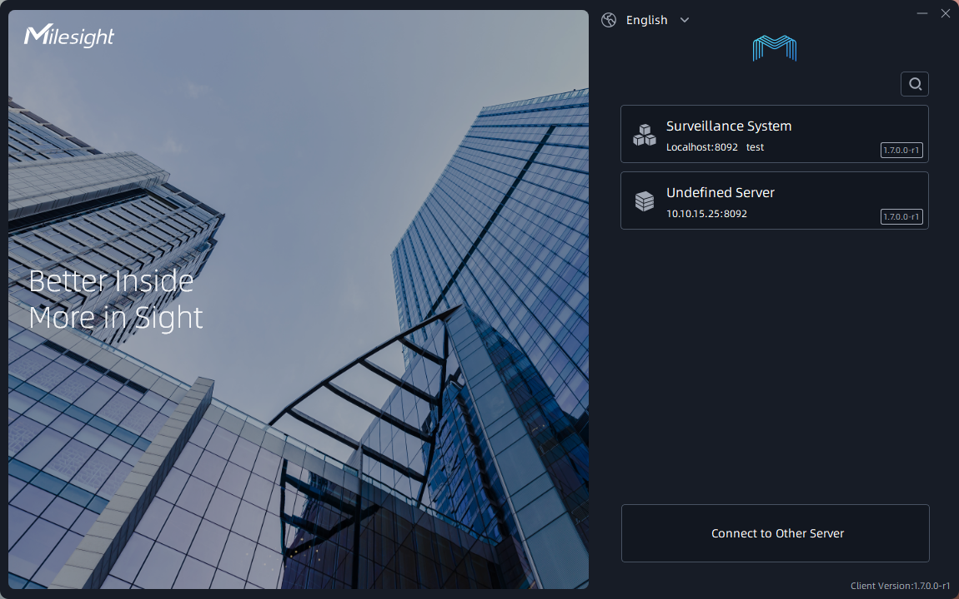

Figure 1.Front Page of Milesight VMS

* **System features:**

**- Video Recording and Storage:** Milestone VMS is primarily designed to record and store video footage from surveillance cameras. This app provides secure video recording with various customizable settings like frame rate, resolution and compression. Up to 8 cameras can be connected at the same time in the free version, but in the more expensive versions, the number will be much larger, possibly up to several thousand cameras.

**- Video analysis:** The software is equipped with advanced video analysis capabilities such as detecting different objects, capturing motion changes, and supporting searching by the above objects.

**- Remote Access:** Milestone VMS allows users to access video footage and analytics from remote locations using a web browser or mobile app. This makes it easy to monitor and manage surveillance activities from anywhere at any time.

**- User Management:** The software comes with a user management module that allows administrators to control access and permissions for each user. It helps ensure that only authorized people can access sensitive video data.

**- Customizable:** The software is highly customizable and can be tailored to meet the specific needs of different organizations. This includes customization of the user interface, video analytics settings, and integration with third-party software.

**- Scalability:** Milestone VMS is designed to handle a large number of cameras and video streams, making it suitable for small to large scale surveillance operations.

**- Reports:** The software provides advanced reporting capabilities that help analyse video data and identify trends. This includes generating reports on video analytics, user access, and system performance.

* **AI Integrated Features:**

Milestone VMS can integrate with a wide range of devices and third-party software such as cameras, access control systems and alarm systems. This provides a seamless and comprehensive security solution for businesses and organizations. Some object detections that Milestone can integrate (need to learn more, not sure):

**- Motion Detection:** Milestone VMS can detect motion in a specific area of camera view and trigger an alert or recording. It can also distinguish between different types of motion, such as human movement or vehicle movement.

**- Face Recognition:** The software can recognize faces in real time and compare them with a database of known faces to identify individuals. This feature is useful in enhancing security and identifying potential threats.

**- License plate recognition:** Milestone VMS can recognize and read license plates on vehicles and compare them with a database of known license plates to identify the vehicle or follow it. track their movements.

**- Object Detection:** The software can detect and track specific objects in the camera view, such as bags or packages, and trigger alerts or logs based on rules predefined.

**- People Count:** Milestone VMS can count people entering and exiting a specific area, such as a store or building. This feature is useful in managing crowds and improving customer service.

**- Audio Analysis:** The software can analyse audio data from the camera and microphone, and detect specific sounds, such as gunshots or broken glass, and activate alarm or recording.

**- Heat Map:** The software can generate heatmaps showing the frequency and duration of activity in the camera view. This is useful in analysing customer behaviour and optimizing store layouts.

**- Object Classification:** Milestone VMS can classify objects in the camera view based on their size, shape and motion. This helps to identify specific objects, such as vehicles or people, and trigger alerts or logs based on predefined rules.

**- Anomalous Behaviour Detection:** The software can detect unusual behaviour in the camera view, such as a person loitering in a restricted area or a vehicle driving in the wrong direction. This helps to identify potential threats and increase security.

**- Mask detection:** Milestone VMS can detect if people in camera view are wearing masks and trigger an alert or record if wearing a mask is required in an area specific area.

**- Distance monitoring:** The software can monitor and detect if people in the camera's field of view are maintaining a safe distance from each other and trigger an alert or record if the social distancing rules are violated.

**- Disappearance object detection**: Milestone VMS can detect when an object has been removed from a specific area of the camera view, such as a piece of art from the gallery. This helps prevent theft and increases security.

**- Camera tamper detection:** The software can detect when the camera is tampered with, such as being covered or moved, and trigger an alert or record.

**- Queue management:** The software can detect and monitor queues or queues in real time, such as in a retail store or at a ticket counter, and generate alerts or notifications. reports to optimize queue management.

**- Perimeter Protection:** Milestone VMS can detect and alert security personnel when someone enters or crosses a predefined perimeter or boundary, such as a fence or wall, to prevent unauthorized access or encroachment.

**- Crowd Detection:** The software can detect and track crowd movements and density in real time, such as during a concert or public event, and create alerts or notifications to manage crowd control.

**- Lour detection**: Milestone VMS can detect and monitor when someone is loitering in a specific area, such as a parking lot or dock, and generate alerts or notifications to increase security.

**- Fall detection:** The software can detect and track when someone falls, such as in a hospital or nursing home, or especially during Finnish winter and generate alerts or notifications to aid in emergency response.

**- Smoke and fire detection:** Milestone VMS can detect and monitor smoke and fire in real time and generate alerts or notifications to enhance safety and reduce response time in case fire.

- **Facial Emotion Recognition:** The software can detect and analyse facial expressions in real time, such as happy, sad, angry or surprised, and at the same time

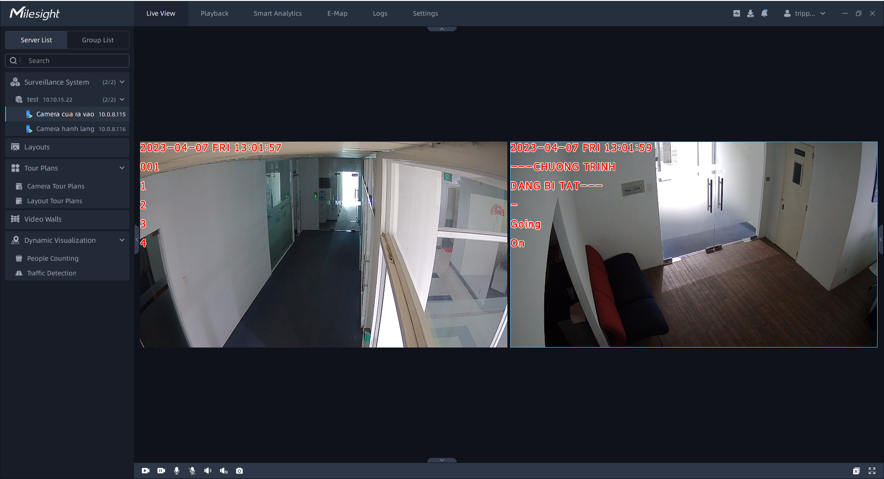

Figure 2 Camera view of Milesight VMS

* **Features that need improvement:**

While the Milesight VMS app is a solid video management system, there are several areas where it could be improved for a better user experience:

- Simplify advanced features and settings to make them more accessible to all users.

- Improve app accessibility by providing alt text for images and icons.

- Resolves crashing and freezing issues reported by some users.

- Provide more detailed documentation and support resources to help users better understand and make better use of the app's features.

- Adjust costs for users, apply promotional campaigns for newcomers or long-term use packages to retain customers.

- Smartphone or mobile devices integration, which is not optimized

### VMS Axis

AXIS Camera Station is a comprehensive video management software designed for small and medium businesses, there are many similarities between Axis and Milesight. However, the integration feature of Axis is considered more convenient because it can allow users to integrate with their smartphones.

* **System features:**

**- Live View:** The live view feature allows users to observe streaming video in real time. This feature provides continuous frames of the current state in the security area.

**- Recording:** Axis Camera Station supports continuous and event-based recording. Continuous recording records video streams 24/7, while event recording only records video when motion is detected, or an alarm is triggered.

**- Playback:** The playback feature allows the user to play back the recorded footage. It offers several playback options, including fast forward, slow motion, and frame-by-frame viewing.

**- Motion Detection:** supports motion detection, can trigger recording and alert when motion is detected in the monitoring area.

**- Alarm Management:** supports alarm management, allowing users to configure and manage alarms for different events, such as motion detection, fake camera impersonation and network problems.

**- Mobile App:** The Axis Camera Station mobile app allows users to access the surveillance system from their smartphone or tablet easily.

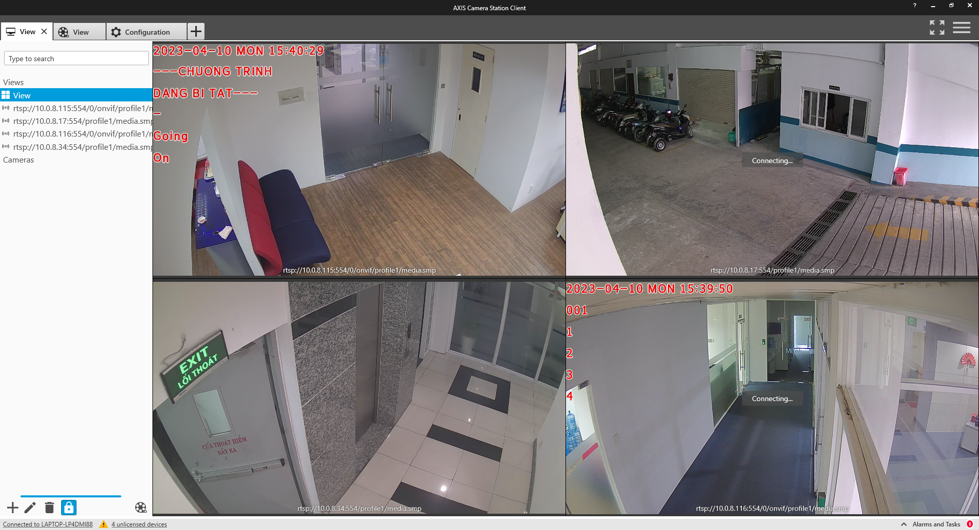

Figure 2 Streaming view of VMS Axis

* **Integration Capability:**

**- Third-party device integration:** Axis Camera Station supports integration with third-party devices, such as access control systems, intercoms, and alarm systems motion. This integration enables a more comprehensive security solution that can be managed from a single interface.

**- API:** Axis Camera Station provides a wide range of APIs that allow integration with other software solutions. These APIs include goofAPI HTTP, VAPIX API, and ONVIF API.

**- Integrating Video Management Software (VMS):** Axis Camera Station can be integrated with other VMS solutions, such as Milestone and Genetec. This integration enables a more comprehensive video surveillance solution.

**- Cloud integration:** Axis Camera Station can be integrated with cloud-based solutions, such as Microsoft Azure and Amazon Web Services (AWS). This integration allows remote access to a cloud-based video surveillance and storage system.

**- Video Analytics Integration:** Axis Camera Station supports integration with video analytics solutions, such as Axis Video Analytics and BriefCam. This integration enables the use of advanced video analytics and can provide more insight into video footage.

* **Features that need improvement:**

**- Resource-intensive live view:** Live view can be resource intensive, which may affect system performance. This problem can be solved by optimizing the live view feature to reduce its resource usage.

**- Storage Management:** Continuous writes can result in large amounts of data, which can be difficult to manage. Axis Camera Station can improve storage management to make it easier for users to manage their recorded footage. And if user would like to integrate the data on cloud service, be careful with the resource cost.

**- False alarms:** Motion detection can be prone to false alarms, which can be frustrating for users. Axis Camera Station can work to improve the accuracy of motion detection to reduce the frequency of false alarms.

**- Alarm Management:** Setting up and managing alarms can be time consuming. Axis Camera Station can improve its alarm management capabilities to make the alarm setup and management process more efficient.

**- Mobile app functionality:** Mobile apps may not provide the same level of functionality as the desktop version. Axis Camera Station can work to improve the functionality of mobile applications to provide users with a more comprehensive remote access experience.

# simulation of an AI cameara application

Gaining insight into the workflows of both the AI and IT teams is critical as an AI system test engineer. This chapter seeks to provide a thorough overview of the tools and procedures used to accelerate AI model training. In addition, we will investigate the creation of a basic smart alarm system – Intrusion Warning. This investigation will not only aid in a deeper understanding but will also be useful while working on smart camera system projects. Let's take the first step in any workflow in the AI industry today, “Implementing a pilot project to gain momentum”.

## Simulation project of an AI training model.

Preparation: Google Drive, Google Collab, training dataset image, training dataset label.

The reason for using the Google Drive and Google Collab toolkit to train an AI model is because these two software execute commands on cloud platforms, ensuring local machine resources are guaranteed to execute some additional tasks. Furthermore, Google Collab’s runtime will be refreshed after a specific time. The question needs to be solved here is: “While the system training a big dataset, is it okay to perform almost tasks like uploading dataset from local machine, setting up, installing, … training model?”

Fortunately, the solution come with Google Drive, where is the best place that we can store dataset folders, training files, .yaml file, … Help us to communicate data, organize files effectively for the training process and performance. Let’s create and set up a drive folder like below:

<https://drive.google.com/drive/folders/1aUHAatJntGiw8ntURGBxJGkLB8wkV2ut?usp=sharing>

* To begin the process of eating the cake up size down. Firstly, focusing on the data folder, the image below would describe the standard file structure for using in training data for a computer vision AI model purpose.

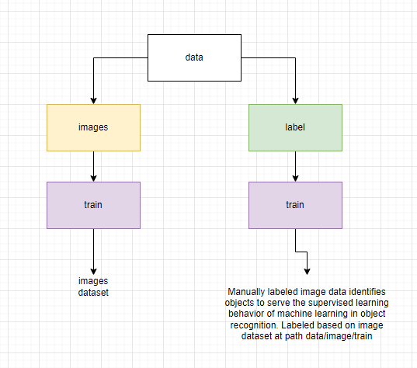

* How can we label the image dataset for supervised learning? There are too many ways or tools these days for implementing those tasks (from opensource, company’s library, company’s software) but let’s explore this process in the fastest and easiest way through an UI Web-based platform through <https://app.cvat.ai/>

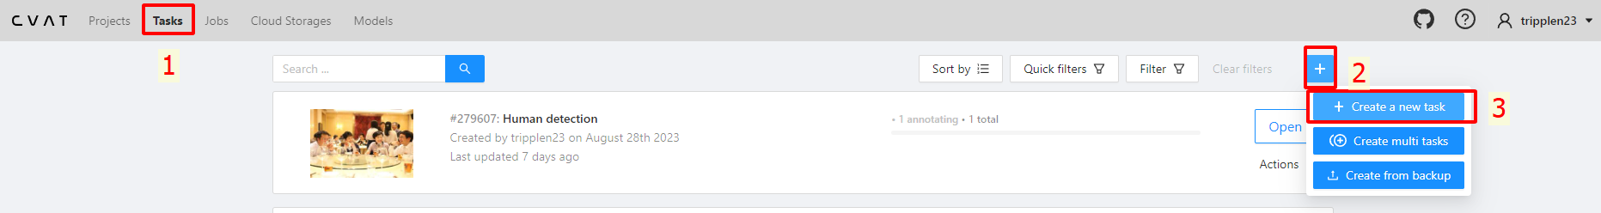

* After registering and signing in, Click the “Task” on the web navbar and then modify on the “+” button and then “Create a new task” button for creating a new task for labeling from an uploaded dataset.

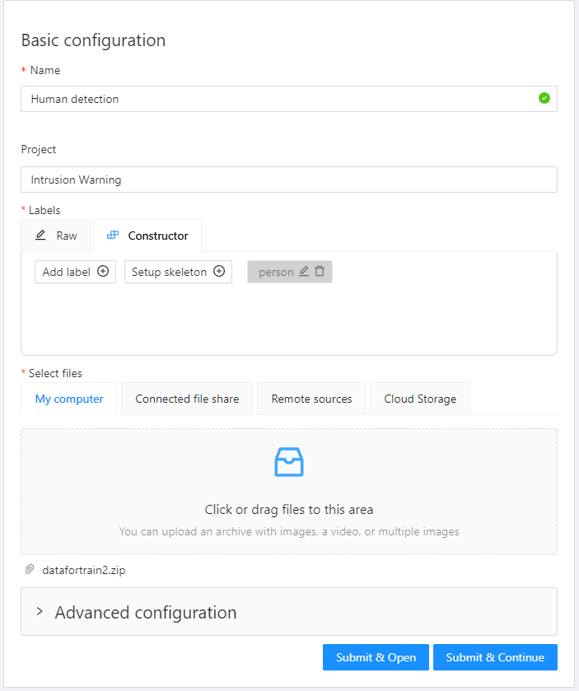

* Modify the task, then click on the button “Submit & Continue”. For dataset, we can collect from our own image data and it is able to download from several Internet resources such as [CrowdHuman Dataset](https://www.crowdhuman.org/)

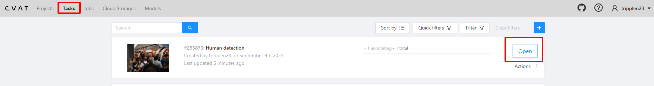

* Go back to the “Tasks” and click on “open” button on the top task (the newest task), then implement the task like the following image:

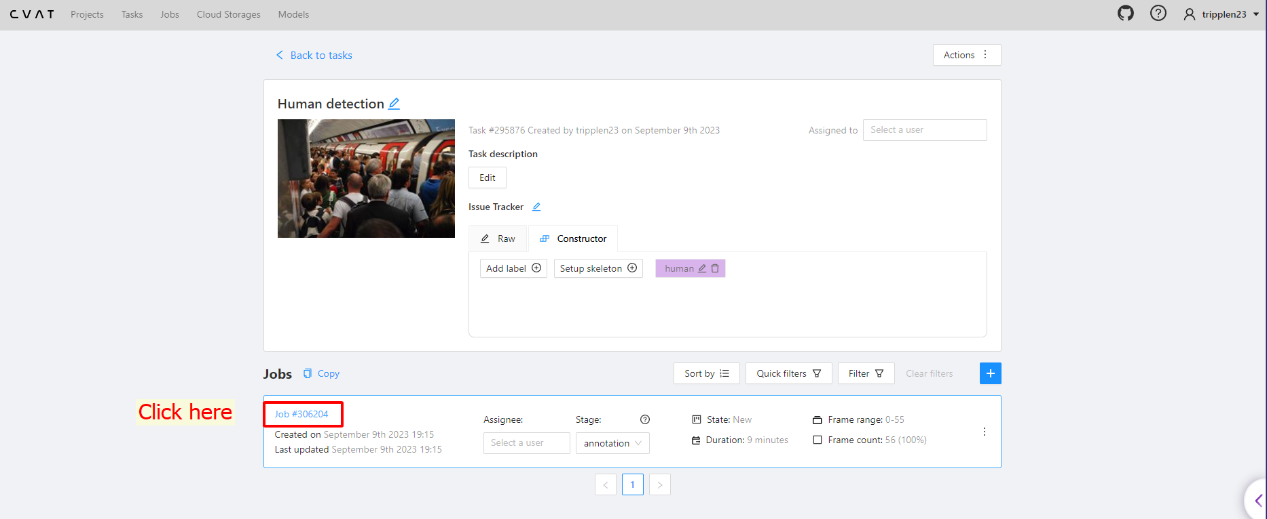

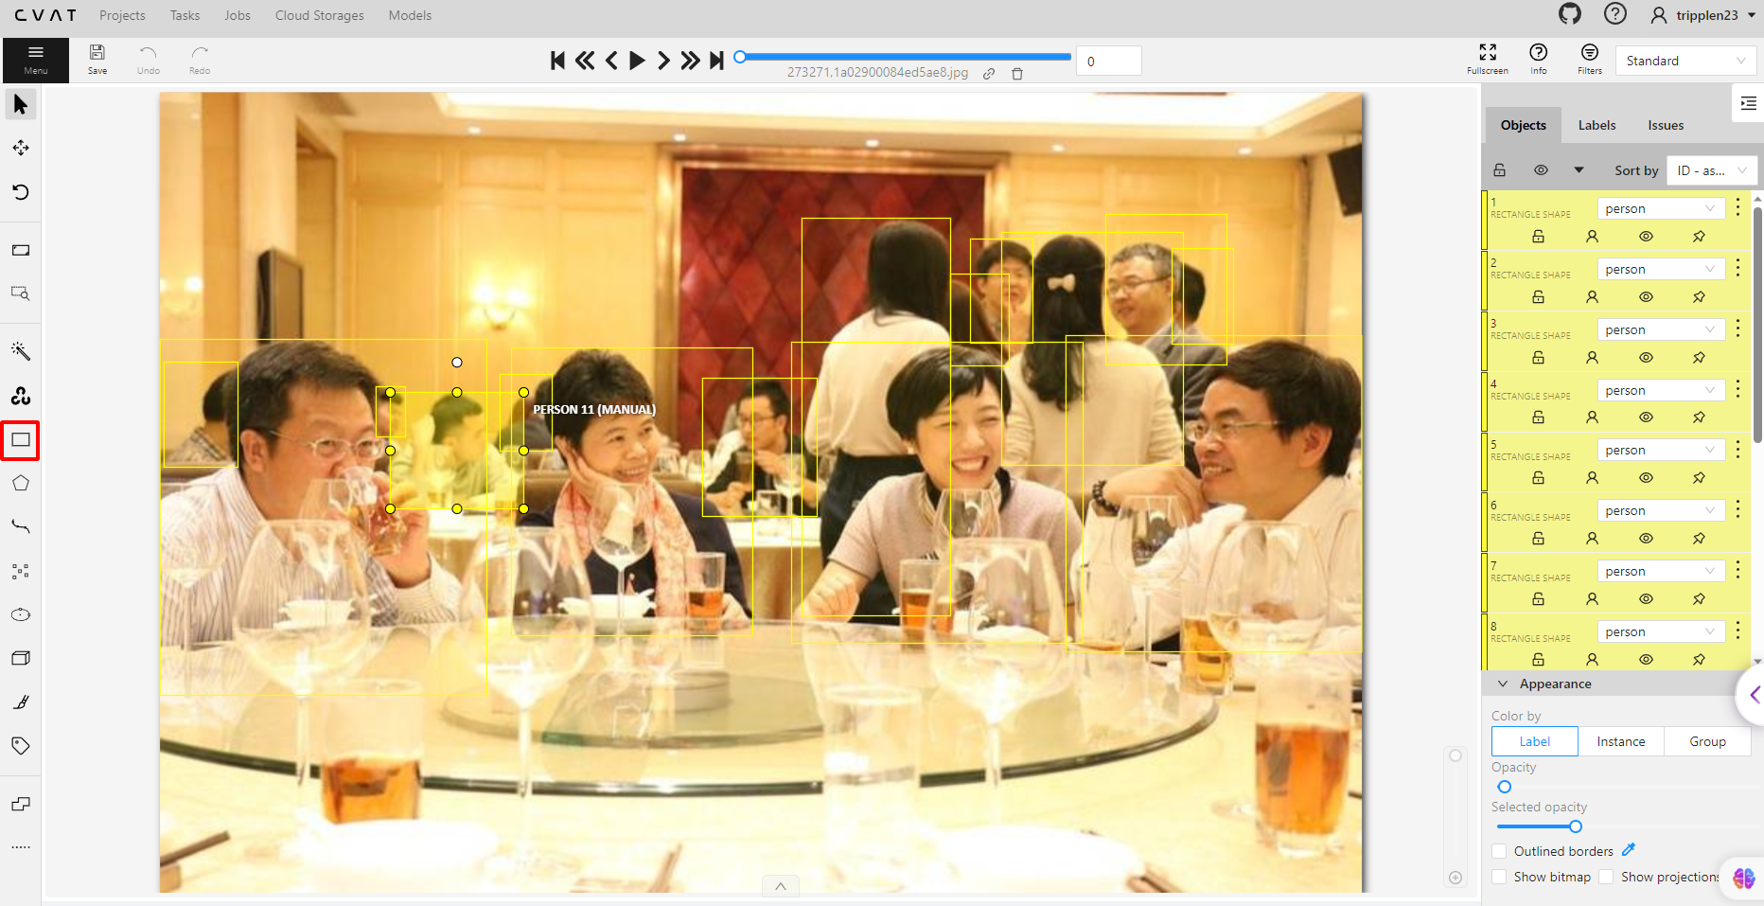

* Click on “Draw new rectangle” button or “Draw new polygon” button or any other options we want, then press the keyboard short “n” for new drawing. We can do this process as much as possible as the more dataset, the more in accuracy for machine to detect our object. Remember to click on the “Save” button after drawing or press the “Ctrl + S ” legendary keyboard shortcut.

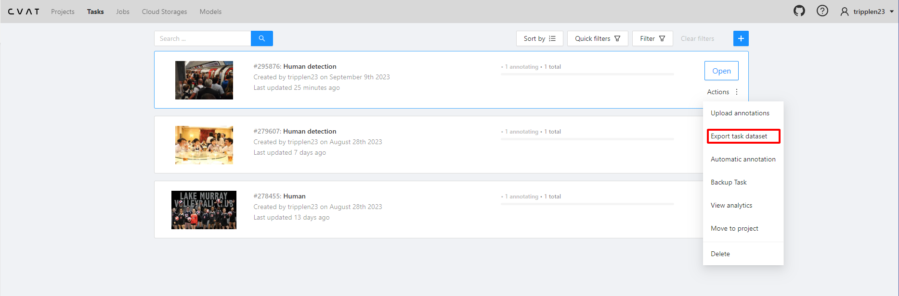

* After labelling all of our dataset, go back to the “tasks” path, hover mouse to “Action” element, then click the section on “Export task dataset”, remember to modify the export format into YOLO1.1 as we will use the source code of YOLO (You Only Look Once) for training our AI model.

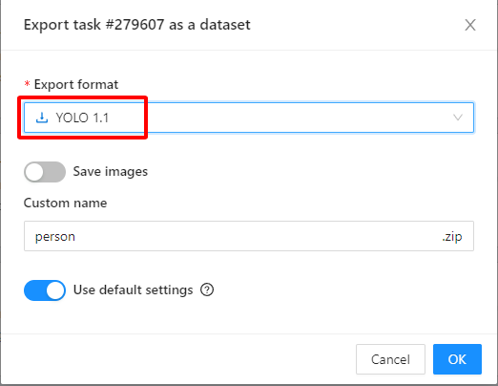

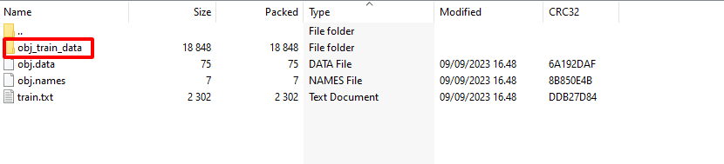

* After exporting, go into the “person.zip” file that we downloaded, there is the folder inside named “obj_train_data”, this folder contains every needed labeled image data for training and for us to place into the path we set up before **My Drive/ComputerVision/TrainYoloV8/data/labels/train**
* Create a google_colab_file.yaml in order to get access into the dataset with the defined classes.

path: "/content/gdrive/My Drive/ComputerVision/TrainYoloV8/data" *# dataset root directory*

train: images/train *# train images (relative to 'path')*

val: images/train *# val images (relative to 'path')*

*# Classes*

names:

  0: human *# or person, it’s up to us*

* Now, let’s modify several code in our Python Notebook Google Collab .ipynb, the first 2 lines are import class ‘drive’ in the google.colab library and then we use it for mounting our Python project to that drive.

from google.colab import drive

drive.mount('/content/gdrive')

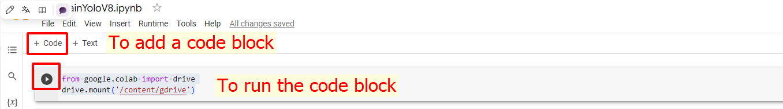

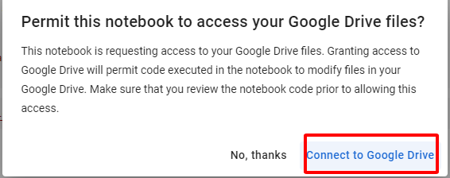

* After signing in successfully on the Drive with the same account we used, the output in the terminal would be:

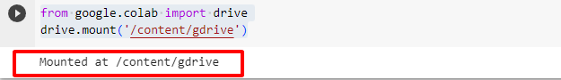

* On the next line, we will initialize a variable “ROOT_DIR” which indicate the root directory on our Google Drive project:

ROOT_DIR='/content/gdrive/My Drive/ComputerVision/TrainYoloV8'

* After running the above code, let’s install the ultralytics library. Ultralytics library is a high-level deep learning library and toolkit that simplifies and enhances the process of training and evaluating AI models, particularly for computer vision tasks. It’s designed to work with popular deep learning frameworks like PyTorch and provide streamlined interface for training, evaluating, and deploying computer vision models.

!pip install ultralytics

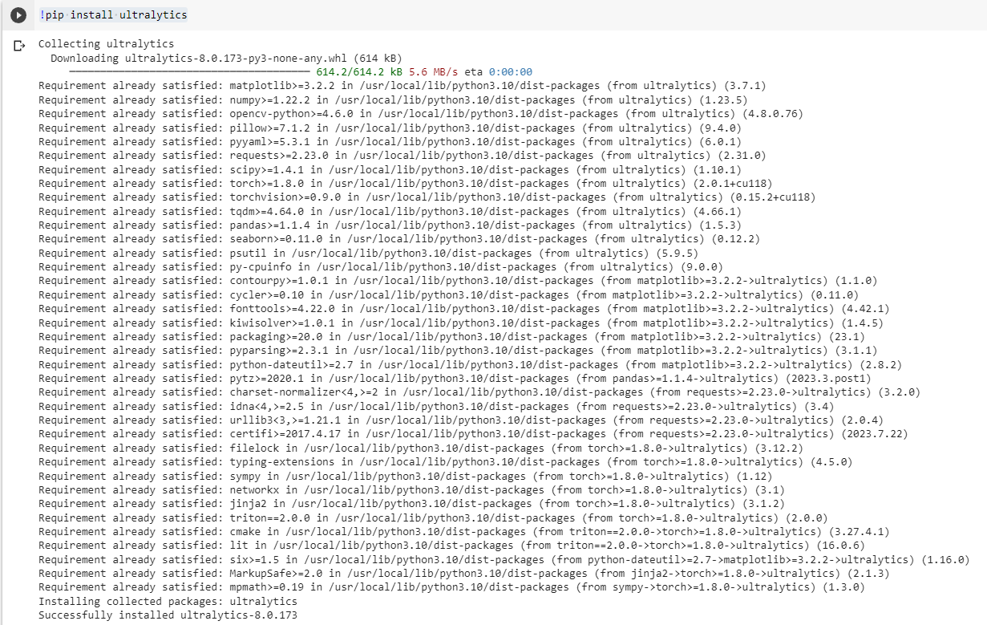

* Then the following code block will be a modified code of a training YOLOv8 model, reference in [ultralytics/ultralytics: NEW - YOLOv8 🚀 in PyTorch > ONNX > OpenVINO > CoreML > TFLite (github.com)](https://github.com/ultralytics/ultralytics)

import os

from ultralytics import YOLO

# Load a model

model = YOLO("yolov8n.pt")  # load a pretrained model (recommended for training)

# Use the model

results = model.train(data=os.path.join(ROOT_DIR, "google_colab_file.yaml"), epochs=1) # Train model

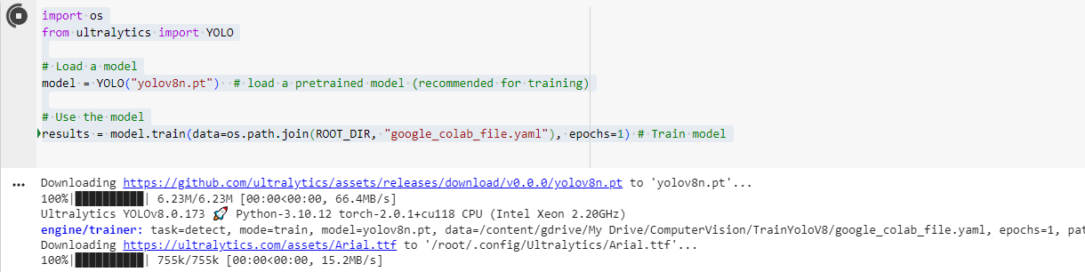

1. **`import os`:** Imports the Python `os` module, which provides a way to interact with the operating system, including file and directory operations.

2. **`from ultralytics import YOLO`**: Imports the YOLO class from the Ultralytics library, specifically for YOLO-based object detection tasks.

3. **`model = YOLO("yolov8n.pt")`**: Creates an instance of the YOLO model by initializing it with a pre-trained model checkpoint named "yolov8n.pt." This pre-trained model serves as a starting point for further training on a custom dataset.

4.**`results=model.train(data=os.path.join(ROOT_DIR**, **"google_colab_file.yaml"), epochs=1)**`: Initiates the training of the YOLO model. Here's what's happening in this line:

- `**data=os.path.join(ROOT_DIR, "google_colab_file.yaml")**`: Specifies the path to a YAML configuration file ("google_colab_file.yaml") that defines the dataset and training settings. `ROOT_DIR` is assumed to be a variable or constant containing the root directory path.

- `**epochs=1**`: Sets the number of training epochs to 1. An epoch is one complete pass through the entire training dataset.

- `**model.train(...)**`: Initiates the training process using the specified configuration file and settings. During training, the model will optimize its parameters based on the provided dataset and training parameters.

- `**results**`: Receives the training results, which can include metrics, losses, and other information about the training process.

Overall, this code loads a pre-trained YOLO model, specifies a custom dataset and training settings through a YAML configuration file, and then starts the training process for one epoch. We can modify the number of epochs and other training parameters according to our specific requirements.

* After trainning the successfully (It may take a time), let’s export our model file and use our trained model with our purpose in the following line:

!scp -r /content/runs '/content/gdrive/My Drive/ComputerVision/TrainYoloV8'

We have now several clarities in a question of how to make a pilot project for training an AI model. The next question is how to make an AI camera system pilot project. The following part of this chapter will go into more detail with the answer. In the next one, we will use a pre-trained model YOLO v3 and have a deep view in how everything is work.

## Intrusion Warning Project (With YOLO & OpenCV)

### What is Intrusion Warning?

Intrusion Warning in the scope of this thesis is a small AI Camera System, which firstly detect an object, specific here is “person” object class by a pre-trained model YOLOv3. Besides, the system allows us to draw a polygon area via our monitored camera, and then update the warning status whenever the centroid of the object detected is inside the drawn polygon area. Furthermore, we will take a look in using a telegram bot API with our app that will notify us whenever the system detect a person is inside our security area. The application is not only applicable in the security industry but also in the marketing strategy, which identify the habit of choosing product of customer, and more and more field of business in our World.

The image below describes clearly about the workflow of our intrusion warning project.

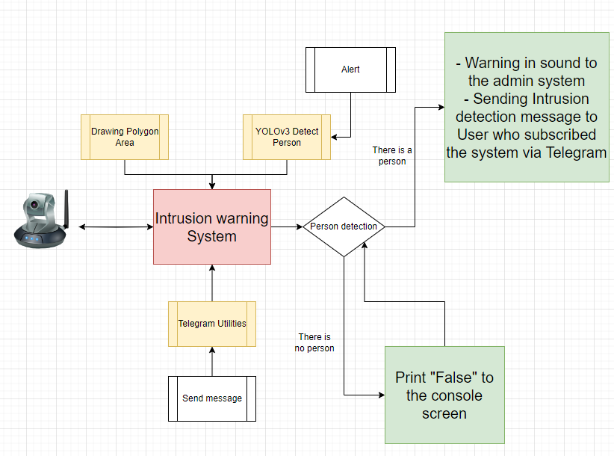

Pipeline:

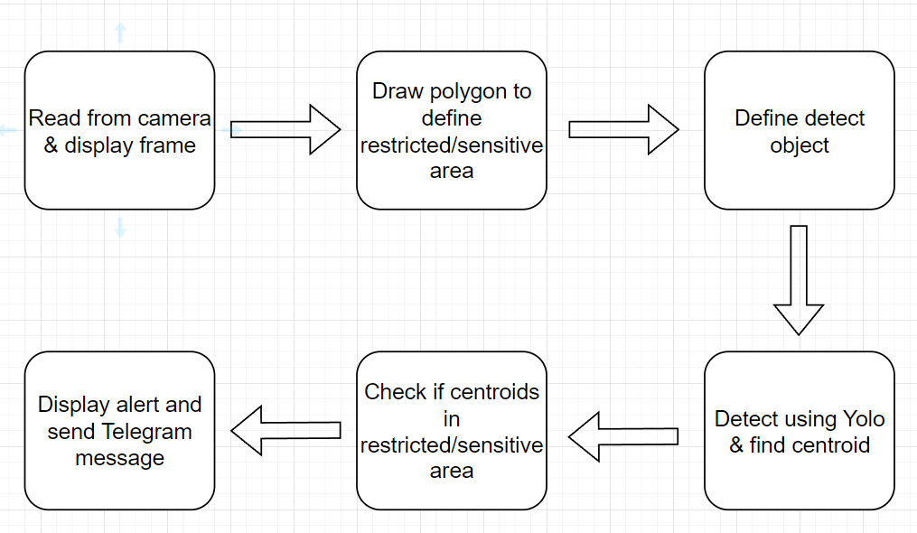

* Firstly, make sure that we create a Camera System that can connect a real camera. Let’s take our webcam for the easiest way for this situation.
* Ensuring that our main system integrates all the different factors includes drawing a sensitive polygon, calculating the centroid point of the object (in this case, a person) and considering whether that centroid point is located in the target area. inside the previously drawn sensitive area.
* If the object's centroid point is in a zoned sensitive area, return a notification on the screen, send a message via telegram bot.
  + If not, continue detecting until the intruder is detected.

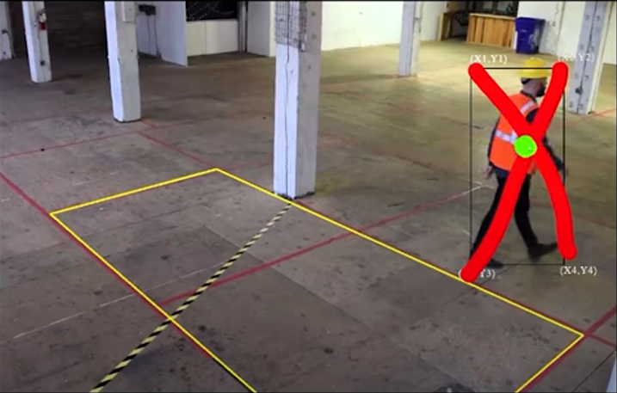

Figure 3: Centroid of human example

So, let’s have together a quick view to the centroid. “The centroid” is a geometric property of an object that represents its center of mass or balance point. For shape like a human body, the centroid point is the average position of all the individual points that make up the object. And in deeper way how we calculate and analyze the centroid point algorithm, move to the next sub-part. The practical time.

### Building Intrusion Warning System application:

Source code: [thesis/Intrusion warning at main · tripplen23/thesis (github.com)](https://github.com/tripplen23/thesis/tree/main/Intrusion%20warning)

Ger the pretrained model here:

Requirement:

* Python > =3.8.
* [Installing Miniconda — miniconda documentation](https://docs.conda.io/projects/miniconda/en/latest/miniconda-install.html) – For creating a Python Virtual Environment on local machine.
* OpenCV – For drawing, implement several tasks like detection, end task, … on our camera, webcam, video screen.
* aiogram==2.15 – Library that handle the sending message task though a Telegram bot.
* Shapely library: Checking if a Point is inside or outside a Polygon.

Let’s get started, Firstly, create an empty folder named “Intrusion Warning” right click on that folder -> Open with Visual Studio Code -> Open new Terminal -> Enter command line “conda activate myenv” for activating our virtual environment



Next, create now a setup.txt file, which indicate required external libraries for our project, the setup.txt have the following content:

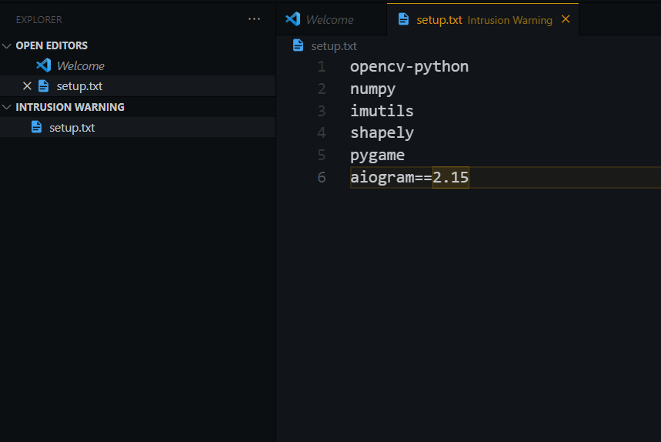

Then, type command line **“pip install -r setup.txt”** for installing all the required libraries.

After that, make sure our application can connect to the real camera, we will take our webcam for implementing this purpose via the “main.py” file.

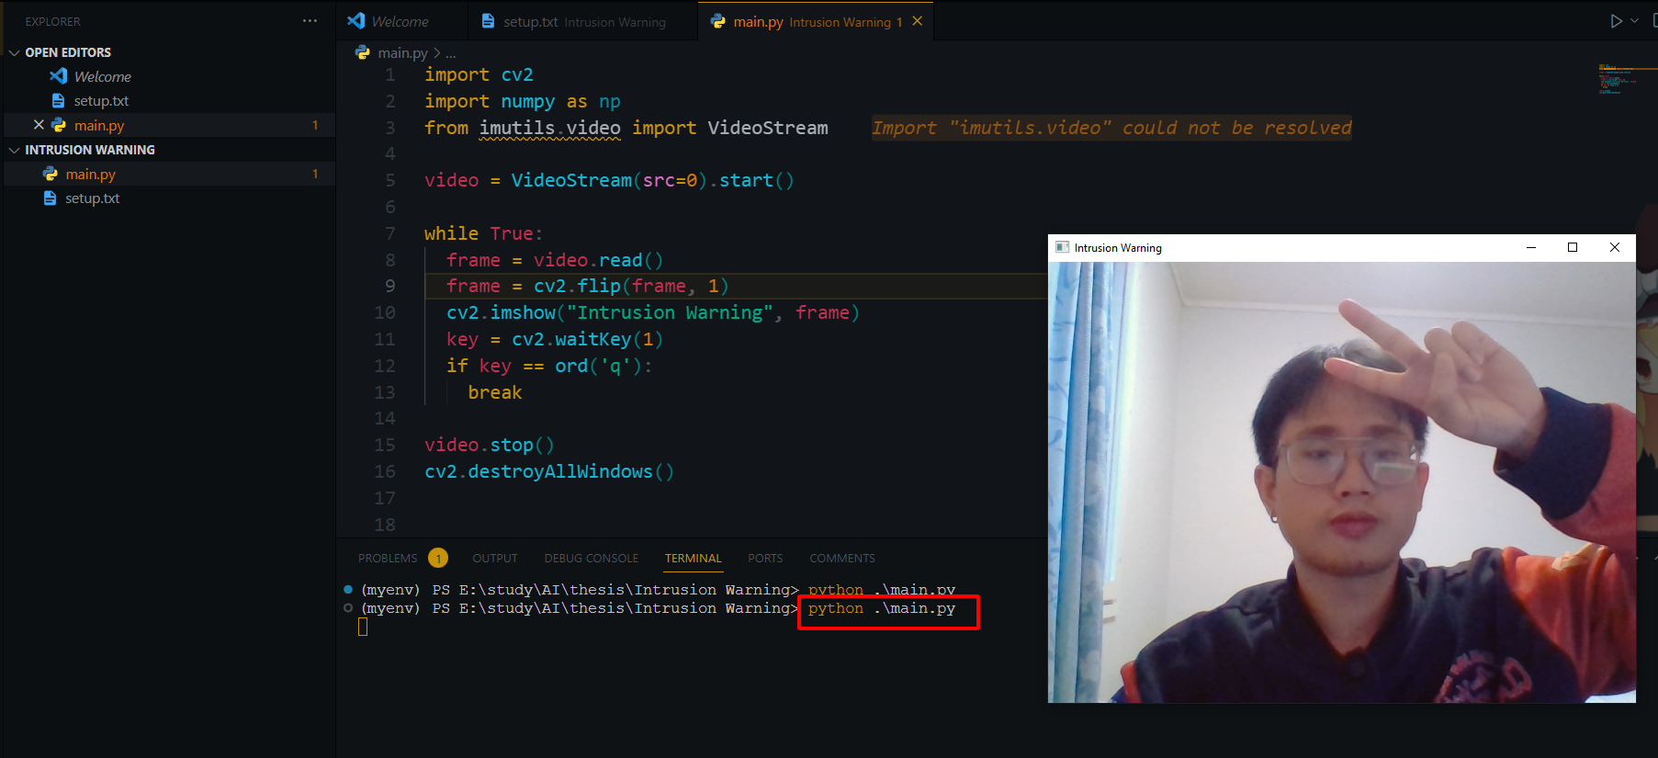

Code Overview:

* Import necessary libraries (Line 1-3).
* Start a video stream from the default camera (src = 0) (Line 5).
* Enter a loop to continuously capture and display video frames **“while True”** (Line 7-13).
  + Flip each frame horizontally (mirror effect) using **“cv2.flip”** (Line 9).
  + Display the flipped frame in a window titled “Intrusion Warning” using **“cv2.imshow”** (Line 10).
  + Continuously check for user input using **“cv2.waitkey(1)”** (Line 11).
  + If the **“q”** key is pressed, exit the loop (Line 12-13).
* Stop the video stream using **“video.stop()”** (Line 15).
* Close all OpenCV windows with **“cv2.destroyAllWindows()”** (Line 16).

The next step, download the pre-trained model from [AlexeyAB/darknet: YOLOv4 / Scaled-YOLOv4 / YOLO - Neural Networks for Object Detection (Windows and Linux version of Darknet ) (github.com)](https://github.com/AlexeyAB/darknet). However, this thesis prepare for us a minimal custom folder to download YOLOv3 [here](https://drive.google.com/drive/folders/1vs-dJ8gL2Gdu4Ns-OaQeiOnF1PzE_oCr?usp=sharing). Our project will look like below in our structure:

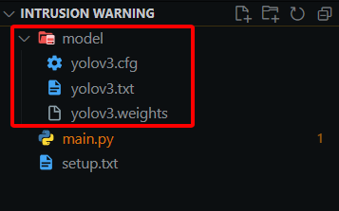

Now, create a new file “detectyolo.py”, copy whole content in [thesis/Intrusion warning/yolodetect.py at main · tripplen23/thesis (github.com)](https://github.com/tripplen23/thesis/blob/main/Intrusion%20warning/yolodetect.py) our new file.

The provided Python code is part of a program designed for real-time object detection, specifically for detecting humans using the YOLO (You Only Look Once) model. It integrates various functionalities, including object detection, drawing bounding boxes, calculating centroids, and triggering alerts. Here's a concise analysis of this code

* Imports necessary libraries and initializes audio playback:
  + OpenCV (cv2): Used for image and video processing.
  + NumPy (numpy): Used for numerical operations.
  + Shapely (shapely.geometry): Used for geometric operations, such as checking if a point is inside a polygon.
  + telegram_utils: Custom module for sending alerts to Telegram.
  + pygame.mixer: Used for playing an audio alert. (Take the file audio/alarm2.wav on the Github source code).

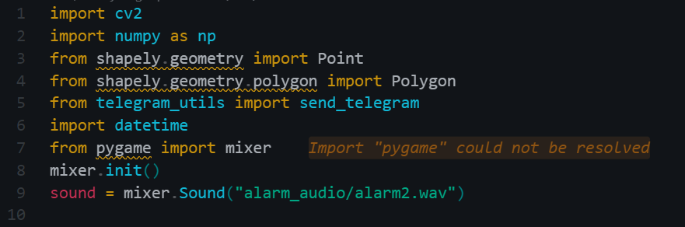

* Defines a function ”isInside(points, centroid)” to check if the centroid of detected person is inside a specified polygon area using Shapely geometry.

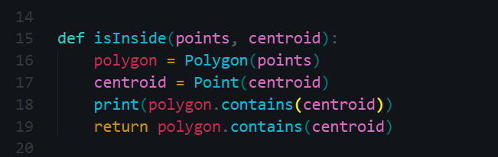

* Defines a class “YoloDetect” class for object detection:
  + Initializes parameters, such as YOLO model files, confidence thresholds, and frame dimensions.
    - Modify the sending telegram alert in each 15 second when detect a object in the restricted area. This helps us avoid sending notification messages continuously, causing negative impacts on server resources as well as inconvenience to users who register for the service.

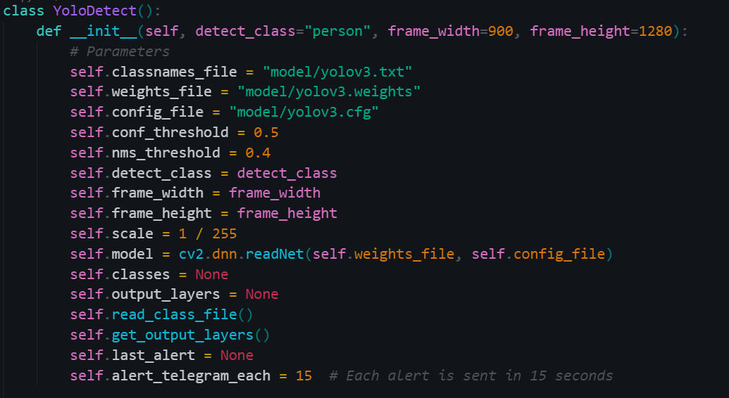

* + Reads class names from a file.

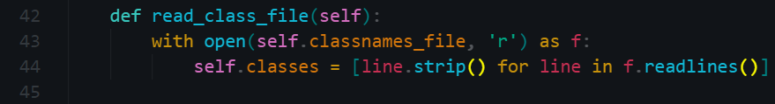

* + Sets up the YOLO model and output layers.

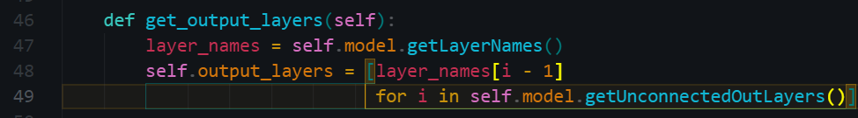

The code blocks provided above serve as the foundational configuration of the YOLO model within our project. The subsequent functions contained within the `YoloDetect` class will play a crucial role in implementing the core functionality of this class. Consequently, let's take a closer look at these functions to gain a deeper understanding of their role and significance within the class

The `draw_prediction` function inside the `YoloDetect` class is responsible for drawing predictions on a given frame based on the results of object detection. It specifically draws bounding boxes around detected objects, labels them, calculates the centroid of each bounding box, and performs additional actions when a centroid is inside a specified polygon area. Here's a detailed analysis of the code and algorithm within the `draw_prediction` function:



Parameters:

- `img`: The input image frame where predictions will be drawn.

- `class_id`: The class ID of the detected object "person").

- `x`, `y`: The coordinates of the top-left corner of the bounding box.

- `x_plus_w`, `y_plus_h`: The coordinates of the bottom-right corner of the bounding box.

- `points`: A list of points defining a polygon area.

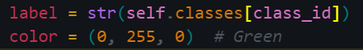

- `label`: Retrieves the class name based on the `class_id`.

- `color`: Defines the color for drawing the bounding box (in this case, green).

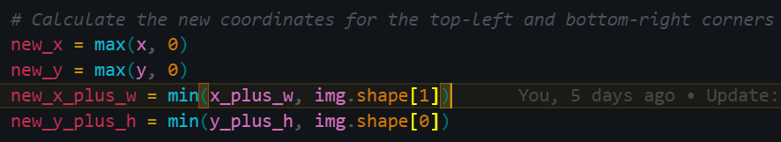

- The code ensures that the bounding box coordinates (`new_x`, `new_y`, `new_x_plus_w`, `new_y_plus_h`) do not extend beyond the image boundaries to avoid errors when drawing.

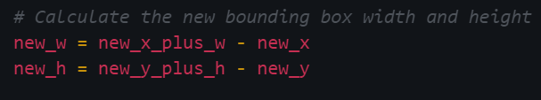

- `new_w` and `new_h` represent the width and height of the adjusted bounding box.

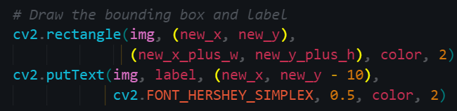

- The code uses OpenCV functions to draw the bounding box and label on the image.

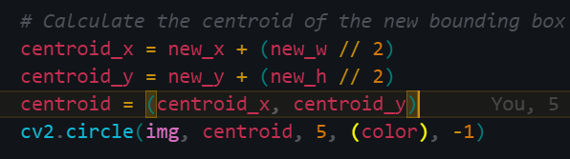

- The centroid of the adjusted bounding box is calculated as the midpoint of its width and height.

- A small green circle is drawn at the centroid position on the image.

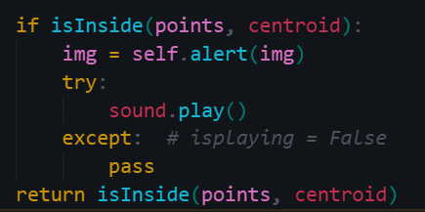

- The `isInside` function is called to check if the centroid of the bounding box is inside a specified polygon area (`points`).

- If the centroid is inside the polygon, an alert is triggered, and a sound is played.

- The function returns a boolean indicating whether the centroid is inside the polygon.

Finally, the 2 methods left in the Class YOLO detect is simply take the responsible for

Triggering an alert from “alert” method:

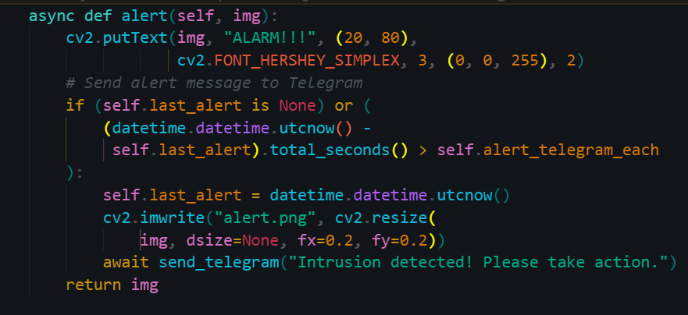

The “detect” method processes video frames

* Converts frames to suitable format for YOLO
* Runs object detection using YOLO and filters results based on confidence and class.
* Draws bounding boxes and centroids for detected humans.
* Triggers an alert when a human is detected inside the polygon.

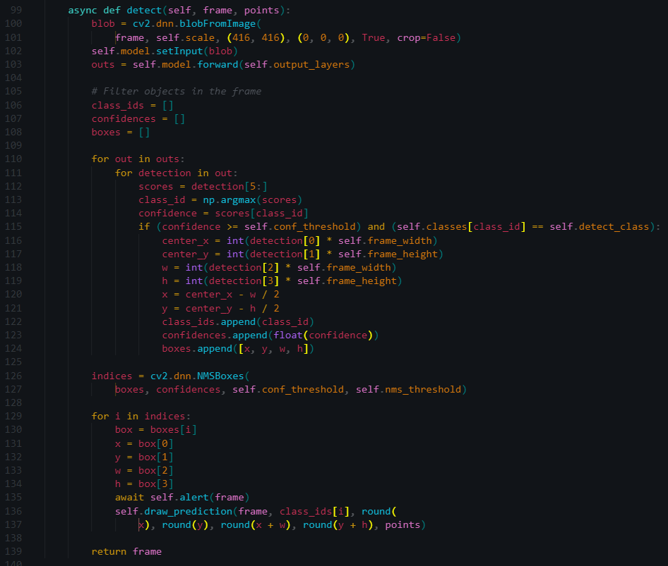

Read the instruction of using telegram bot via Python app in my Github:

[thesis/Intrusion warning/telegram_bot_instruction.txt at main · tripplen23/thesis (github.com)](https://github.com/tripplen23/thesis/blob/main/Intrusion%20warning/telegram_bot_instruction.txt)

After creating a Telegram bot, get Bot ID and User ID, let’s create a file “telegram_utils.py” with following content (remember to use bot token/chat_id that we have created ourselves):

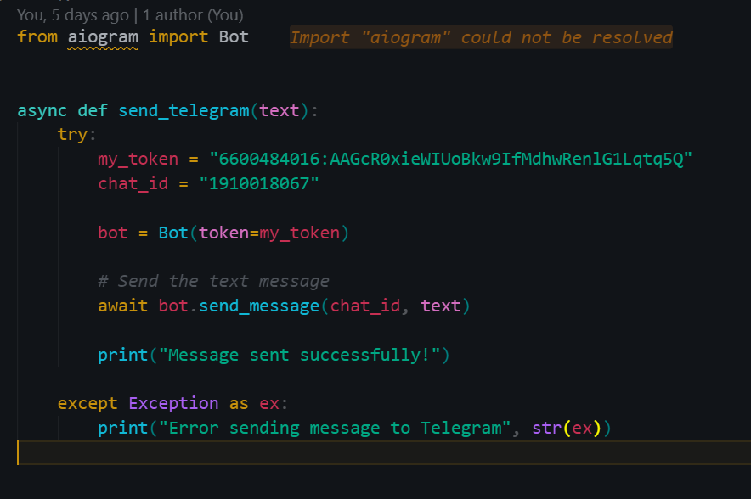

# APPEARANCE

Note the following in the appearance of the text:

1. **Figures,** drawings and photos are numbered with a running number. The word ”Figure” and the number are bolded (e.g. **Figure 1.)** but notthe caption i.e. the text that names and explain the figure.. The caption text ends in a full stop and it is placed under the figure. The figures are separated with a blank line before and after from the text. Make sure that you make reference to figures in the text.
2. **Tables** are separated with a blank line before and after the table. The word ”Table” and the number are bolded (e.g. **Table 1.)** but not the caption. The caption of a table ends in a full stop and it is written above the table.
3. **Formulas** are numbered with a running number. The number of the formula is written inside brackets on the right edge of the text and the beginning of the formula is placed so that all formulas begin at the same spot. An example:

E = mc2 where E=energy (1)

m= mass

c= the speed of light

1. **Appendices** (APPENDIX 2)include information that is not essential to understand the matter being discussed but is referred to in the text. All figures, tables and lists that demonstrate the contents of the thesis but are too big in size or lesser in importance to be integrated in the text are marked as appendices. The questionnaires or interview questions used are also placed in the appendices. They are numbered with a running number. The first matter found in the appendices referred to in the text is then Appendix 1, the next one Appendix 2. If there are many appendices, a list is drawn up and placed after the contents page.

1. **A new chapter** is startedon a new page.Each chapter should have at least two subtitles. In addition, each chapter should contain at least two paragraphs and a paragraph should contain at least three sentences.
2. **To emphasize** the text **bolding**, *italics* etc. can be used but sparingly and consistently. Underlining is not recommended.
3. **Dash (**–**)** is used between limits expressed either in numbers or in words (no hyphen -). E.g. between 1941–1944, items 4–7, September – October, pages 12–15. **In Word, the dash is produced with the combination [ctrl] [minus][1].**

8. Subheadings are spelled so that important words are written with a capital initial. Prepositions and articles are written in small case. The title of the thesis in the abstract is spelled the same way, e.g. This is What a Good Title Looks Like.

# ENDING PHASE – ASSESSMENT OF THE THESIS AND MATURITY TEST

European Qualifications Framework (EQF) is made up of two levels with which the learning results the education learning results are described. The EQF levels describe the depth knowledge, skills, and competence of a learner. EQF has been developed to make it easier to compare different qualifications in the EU. National Qualification Framework (NQF) is used nationally. More information can be found on [Qualifications Frameworks](https://www.oph.fi/en/education-and-qualifications/qualifications-frameworks) can be found on the Finnish National Agency for Education’s website.

The assessment of the thesis is based on EQF standards. See Table 3 (Appendix 2[2]) of the evaluation criteria in use at VAMK and the criteria for the UAS Master’s degree in Table 4 (Appendix 4[3]). The emphasis of evaluation is on the student’s input, the novelty value and of the work and its applicability to practice and the documentation of the work.

## The Presentation Time of the Thesis

The time for the presentation of the thesis is agreed with the supervisor and the supervisor will appoint an opponent for the presentation. A written thesis report is submitted to the supervisor and the opponent at least two weeks prior to the presentation.

In thepresentation seminarthe student presents his/her completed thesis orally to the audience in the language of the degree programme. The students act as opponents in turns. The opponent’s task is to ask questions and assess the thesis and the presentations critically but in an appropriate manner. The aim is to bring up the strengths and weaknesses of the thesis and the opponent’s reasoned opinions on the thesis. The opponent fills the in Opponent’s Assessment Form and submits it to the supervisor of the thesis at the presentation occasion. The presentation seminar is public and the listeners have a possibility to ask questions from the author of the thesis.

## Maturity Test, Bachelor’s Degree

The maturity test is based on the Universities of Applied Sciences Decree [(1129/2014 8 §)](http://finlex.fi/fi/laki/ajantasa/2014/20141129) which states that for the Bachelor’s degree the student must write a maturity test on the field of the thesis, which shows knowledge in the field and good language skills. The UAS will decide on the language when the student has received prior education in other language than Finnish or Swedish and 7 § of the said Decree does not apply to them.

In its Degree Regulations (1.8.2022) in 9 § VAMK has declared that “to be awarded a degree, the student has to write a maturity test related to the topic of the thesis. The maturity test demonstrates knowledge in the field and skills in Finnish or Swedish. The maturity test is written in the language of the student’s primary and/or secondary education. If the student has received primary and/or secondary education in some other language than Finnish or Swedish, the maturity test is written in the language of the degree programme or the Director of Unit can agree with the student about taking the maturity test in some other language.”

The students studying in English-medium degree programmes, who have received their primary and /or secondary education in Finnish or Swedish, write the maturity test in Finnish or Swedish, not in English.

The student agrees with the supervisor on the writing of the maturity test. The objective of the maturity test is to show that the student masters the topic of the thesis and the language. The maturity test is written in a supervised test situation without any source material on paper or as an electronic examination in EXAM-system. Maturity test can also be an online essay. The supervisor gives two topics of which the student chooses one. The topic can be a heading or phrasing of the heading can be left to the student.

When written on concept paper, the standard length of the maturity test is approximately four pages with writing on each line, if the paper in questions is large-checked and writing on every other line if the paper is small-checked, approximately 450-600 words. Length of the EXAM maturity test and online essay is also 450-600 words.Three hours is given for writing the maturity test. The assessment is pass or fail. Both the supervisor and language teacher assess the maturity test. Students with dyslexia have the right for special arrangements, provided that they have an expert’s statement on dyslexia.

Maturity test can also be offered to be published as an article in Vaasa University of Applied Sciences Energiaa web magazine, after supervisor’s content and language checking. In aforementioned case, the publication instructions of web magazine applies to maturity test published as an article. Student must include permanent URN address of thesis (Theseus link) as a refence to the article.

Requirements for an approved maturity test:

1. The contents of the maturity test and that of the thesis have to correspond with each other.

2. The text is readable, and it is easy to tell the capital letters and small letters and words apart.

3. The writing has a headline. The headline and the contents have to correspond with each other.

4. The text is divided into paragraphs*.*

5. The spelling and use of punctuation is correct.

6. The relation between the sentences and clauses are clearly stated.

7. The word order is unambiguous and in harmony with the information given.

8. The style of the writing is formal.

9. The text is based on language, notfor example on diagrams, charts or figures.

10. The writing is a well-structured and a unified entity.

11. The reader has to be able to understand the text as its own entity. The writer must not presume that the reader is familiar with the thesis.

The student can be failed in the maturity test if there are severe or reoccurring errors or defects in the contents or language. The student can register for a retake, having looked into the checked maturity test and having received guidance on the writing. The language of the maturity test is stated in the diploma.

## The Maturity Test for the Master’s Thesis is a Thesis Press Release

The student who completes a Master’s Thesis at VAMK has two options regarding the maturity test, one is to write a thesis press release and the other one is to write a traditional maturity test[4]. The student agrees on the choice with the supervisor.

A press release maturity test written is written in a formal style and in an interesting way. The test is written in the student’s language of primary/secondary education. The press release is typed in font size 12. The length is two pages in maximum.

The most important information of the press release is placed at the beginning of the text and other, supplementary, information is subsequently added towards the end of the document. The main points are highlighted in the heading and in the lead paragraph. In other words, the aim is that headline captures the essence of the research. The headline is followed by a lead paragraph, which complements the headline by presenting the central content of the research. The body text of the press release subsequently presents the research through concise description, justification and illustration of the results.

It is assumed that the reader of the press release is interested in the topic area. The press release answers the questions: what was researched, who did the research, where did the research take place, when, how (methods), why was the research of importance, who did it and who supervised it. The most important information is placed at the beginning and supplementary information at the end.

The text must be linguistically concise, understandable, written in clear formal language and according to Finnish, Swedish or English language standards. Use short phrases and divide the text into paragraphs. As the press release is written for the so called general public, avoid complicated professional terminology. If it is still necessary to use some professional terms, remember to explain them.

At the end of the press release, under the heading “Additional information” (“Lisätietoja”, “Tilläggsinformation”) the name of the person who can give additional information on the topic is given. In practice, this is the name and contact details of the writer of the thesis.

After the approval of the press release, the student can freely use it for her/his own purposes. The supervisor of the thesis forwards the press release to the communications department of VAMK and they can use it as a press release if they wish. The student can be failed in the maturity test written as a thesis press release if there are inadequacies or deficiencies in contents or language.

**Additional information**

Opiskelija, O. 2017. Vientikaupan haasteet ulkomaan kauppaa aloittelevassa yrityksessä. Opinnäytetyö. Koulutusala, tutkinto-ohjelma. Vaasa: Vaasan ammattikorkeakoulu.

Oili Opiskelija, YAMK, Liiketoimintaosaaminen, Vaasan ammattikorkeakoulu [oili.opiskelija@edu.vamk.fi](mailto:oili.opiskelija@edu.vamk.fi), GSM 040 123 4567.

Opinnäytetyö on tallennettu Theseus-tietokantaan osoitteessa <https://publications.theseus.fi/>.

The supervisor’s / supervisors’ name(s) are added at the end.

If the student chooses the traditional maturity test, or s/he has not earlier written a maturity test in a previous educational programme, the supervisor gives two alternative headings for topics that the student can choose between. The supervisor can either give a headline for the topic or it can be left to the student to formulate an exact headline for the topic given. The maturity test is written in supervised situation without any material available.

The length of the maturity test is approximately 450-600 words, written on every line if the square size of the graph paper is of the larger type (7 mm) and on every second line if the square size is smaller (5 mm). The time for writing is 2 h and 15 min (135 min). The maturity test is assessed by the supervisor and the language proofreader and the grading scale employed is pass/fail. A person with a dyslexia is entitled to special exam arrangements provided that the student has a dyslexia certificate issued by an authorized person.

For passing, a maturity test must meet the following requirements:

1. The content of the maturity test must correspond to the topic of the thesis.
2. The text is readable; it is easy to tell capital letters and lower case letters and words apart.
3. The text has a headline. The content must reflect the headline.
4. The text is divided into paragraphs.
5. The spelling and use of punctuation is correct.
6. The relation between clauses and sentence is clear.
7. The word order is unambiguous and resonates with the presented information.
8. The language is formal and academic in style.
9. The text is based on language, not on charts, formulas or figures.
10. The text well-organized and a coherent entity.
11. The reader understands the text as a whole. The writer cannot assume that the reader is familiar with the thesis.

The student can be failed in the maturity test can be failed if there are remarkable and reoccurring deficiencies or mistakes in content, language or layout. The student can sign up for a retake of the maturity test after having seen the corrected test and after receiving additional guidance. A note on the language of the maturity test is included in the graduation certificate.

Instructions for Publication

AS states above, the thesis written for A UAS degree cannot be classified entirely. Therefore, the student has to tell the client explicitly that after the thesis has been published in Theseus, it is available for everyone on the Internet. If the thesis contains such confidential information from the client’s perspective, which can be deemed classified for a legal reason, such information can be annexed with the thesis and the annex can be classified. The thesis can also written so that the name of the client is not disclosed.

After the supervisor has approved the final version of the thesis, the student is to

Primarily enter **the final version** of the thesis on the Theseus- electronic library in pdf-format, before applying for the graduation. Log in to Theseus using HAKA credentials (Log in). The thesis can be converted to pdf-format in the word processor by choosing “Save as” and then by choosing pdf as a file format. The thesis is saved at the address [www.theseus.fi](http://www.theseus.fi). While saving, you will be inquired if you wish your thesis to be dealt with like a book (all rights reserved) or do you want a so called creative commons licence for your thesis, which means that other people may use your thesis without your permission. You will also have to give an email address to which information of the saved thesis is sent, as well as your student number and password. Possible large attachments can be saved separately. The thesis will not show immediately in Theseus but the library staff will first check the saved information and publish the thesis after that. If the thesis has more than one author, only one of them saves the thesis in Theseus. Additional information can be found at <http://www.theseus.fi/web/guest/ohjeita>.

If student does not give permission to publish thesis in open collection of Theseus, he/she submits the thesis into restricted collection. Universities of Applied Sciences in Finnish higher education recommend the open collection based on the declaration for open science. More information at <https://submissions.theseus.fi/en/index.html>

In case of technical problems, please contact [pirjo.teppo@uwasa.fi](mailto:pirjo.teppo@uwasa.fi), telephone +358 29 449 8255

A completed thesis has to include all the data needed to assess the objectives of the thesis, the reliability of the process, conclusions and their generalisation. If the thesis is a unique work, a presentation or an exhibition, it has to be documented in pictures or video so that one can get a good idea of the thesis without seeing the original production.

Removing the thesis from the database or submitting a new version of it is possible only in exceptions, and even then only through the supervisor.

The library will receive an email notification when the student has sent the thesis to Theseus. The library staff will publish the thesis but due to seasonal backlogs, this may take a while. The student can graduate even though the thesis has not been published in Theseus if there is proof that it has been submitted there.

## Thesis Assessment, Bachelor’s Thesis

The assessment of the thesis is done by the thesis supervisor. The opinion the possible client of the thesis work about the level of the thesis and its usability are taken into account. When the thesis supervisor has given the student the permission to publish the work, the student turns in the thesis passport (or alternatively checks out the process in Wihi).

The thesis can be graded after the student has presented the thesis is a seminar, written the maturity test, submitted the thesis to Theseus.

The theses are assessed on the scale from 1 to 5 and attention is paid to the management of the research or project process, theoretical background, implementation, results and reporting. The EQF level 6 criteria have been taken into account in the assessment criteria. If the supervisor suggests either grade 1 (pass) or 5 (excellent), another examiner will have to read the thesis as well.

In an excellent thesis (5) the topic of the thesis develops the professional field and it is of importance for the field. The theory of the thesis or the project and the practical application form a clear unified, and logical entity. An excellent thesis also discusses the reliability of the work and the results as well as the validity of the used study methods. In an excellent research based thesis qualitative and/or quantitative research methods have been used very well paying attention to evaluating the used qualitative/ quantitative method. In an excellent project a high level of professional understanding and skill and is shown and in addition the used methods and the reached results have been estimated.

**Thesis Assessment, Master’s Thesis**

The thesis can be assessed when the thesis supervisor has given permission for publication. The supervisor is in charge of the assessment. The supervisor will take into account the possible client’s opinion of the quality of the thesis as well as the usability of the thesis in practice.

The thesis is assessed on the scale from 1 to 5 and attention is paid to the selection of topic, management of the research or project process, theoretical background, implementation, results and reporting. In a Master’s Thesis the assessment criteria are based on the EQF 7 level criteria. In an excellent thesis (grade 5) the topic is significant with regard to the development of the field and the theory and practical part of the research or project together form a clear and logical entirety. In an excellent thesis, the reliability of the results and suitability of the methods (validity) have been dealt with. In an excellent project, commendable expertise has been shown, and methods used and results have been assessed.

If the supervisor suggests either grade 1 (pass) or 5 (excellent), another examiner will have to read the thesis as well. The assessment criteria for a Master’s Thesis can be found in the appendix (Appendix 3) and on VAMK’s webpages under Thesis/Master’s Thesis assessment criteria.

# references

Albertson, S. 2004. Managing research process as an essential resource for improving organizational performance. International Journal of Research 53, 5, 515-521. Accessed 22.9.2016. doi: 10.1005/s10551-008-9988-Y

Black, S. 2013. Consumer Research from Ethical Point of View. Accessed 22.9.2016. http://black.findarticles.zez/p/articles/mi_m1365/is_12_31

Bryman, A., & Bell, E. 2011. Business Research Methods. Oxford. Oxford University Press.

Deal, J. & Prince, D. 2007. Developing Assessment of Learning. Accessed 21.10.2016. http://site.ebrary.com/lib/vamklibrary/docDetail.action?docID=10185362&p00=learningandassessment>

Digh, P. 2009. One pedagogical style does not fit all. Education Magazine 47, 11, 79-81. Accessed 22.10.2016. http://proquest.umi.com/pqdweb?index=1

European Commission 2016. Learning Opportunities and Qualifications in Europe. Accessed 22.10.2016. <https://ec.europa.eu/ploteus/search/site?f%5B0%5D=im_field_entity_type%3A97>

Hirsjärvi, S., Remes, P. & Sajavaara, P. 2001. Tutki ja kirjoita. Helsinki. Tammi.

Hirsjärvi, S., Remes, P. & Sajavaara, P. 2009. Tutki ja kirjoita. Helsinki. Tammi.

L 14.11.2014/932. Ammattikorkeakoululaki. Finlex. Accessed 27.10.2017. http://www.finlex.fi/fi/laki/alkup/2014/20140932.

Metsämuuronen, J. 2006. Tutkimuksen tekemisen perusteet ihmistieteissä. 3. edition. International Methelp Ky. Jyväskylä. Gummerus Kirjapaino Oy.

Pommelin-Andrejeff, L. 2020. Kovakantisen version toimittaminen/oppariohje. 6.8.2020. Email Leena.Pommelin-Andrejeff@vamk.fi Printed 6.8.2020.

University of Portsmouth. Writing about others Work: Using Direct Quotation. Accessed 9.2.2021. <https://www.port.ac.uk/student-life/help-and-advice/study-skills/research-reading-referencing-and-citation/writing-about-others-works-using-direct-quotations>.

Walliman, N. S. R. 2011. Research Methods: The Basics. London. Routledge.

**APPENDIX 1**

**Thesis passport** (to be given to the supervisor for filing after the thesis is finished). **N.B. Wihi platform can be used for monitoring as well.**

Name of student ___________________________________

Group _____________________

Contact information________________________________________________________________

Topic of thesis ___________________________________________________________________

Client __________________________________________________________________________

At latest Date Signature

1. Introduction to thesis and related assignments completed

_______ _______ ________________

1. Approval of topic _______ _______ ________________
2. Thesis plan approved _______ _______ ________________
3. Interim seminar presentation held ________ _______ ________________
4. Contents of thesis approved ________ _______ ________________
5. Layout and language approved ________ _______ ________________
6. Abstract in foreign language accepted ________ _______ ________________
7. Thesis submitted to the opponent ________ _______ ________________
8. Participation in presentation seminars

- excluding acting as an opponent and own presentation

1. ______________________________________ _______ ________________

2. ______________________________________ _______ ________________

3. ______________________________________ _______ ________________

4. ______________________________________ _______ ________________

5. ______________________________________ _______ ________________

6. ______________________________________ _______ ________________

1. Presentation of own thesis held _______ ________________
2. Acting as an opponent (title/student)

____________________________________ _______ ________________

1. Maturity test accepted _______________________

1. I hereby assure that I saved my thesis in electronic form into Theseus at the address

________________________________________________________________________

Address Signature of the student

APPENDIX 2

**APPENDICES**

You can enclose as appendices for example a questionnaire used in the study or other material that is related to the study.

Material that the client wished to classify can be enclosed as an appendix; in this case, the appendix is not included in the published version submitted to Theseus or in the hardbound version.

**THE TITLES AND NUMBERING OF APPENDICES**

The appendices are numbered and given a title. When you refer to an appendix in the text, use the correct referencing practice. Remember to mention the number of the appendix.

Table 3. Thesis Assessment Criteria

|  | **Excellent (5) - Very good (4)** | **Good (3)** | **Satisfactory (2) - Passable (1)** | **Fail 0** |
| --- | --- | --- | --- | --- |
| **Choice of topic** | The topic is significant and current with regard to  developing the field of study. The topic meets the need of the client from the working life. With respect to the choice of topic, the student is able to question and justify the development needs in his/her field of study. The topic is, from the point of view student's professional knowledge, skills and qualifications, innovative and opens up new perspectives in working life. | The topic meets the needs of the client. With respect to the choice of topic, the student has an understanding of the development needs in his/her field of study and is able to analyse them and present them in logically. The topic develops the student's professional knowledge, skills and qualifications and is challenging | With respect to the choice of topic, the student recognises the development needs in the field. The topic corresponds to the student's professional knowledge, skills and qualifications. The topic develops the student's knowledge and skills, and the student is able to justify in what way | The choice of the topic is not based on the proven needs of the working life nor to the development of the field of study. The minimum requirements of Polytechnic Degree (EQF 6) are not me |
| **Knowledge basis** | The student has built up the knowledge basis of selected diverse sources that are relevant to the topic. S/he is able to make syntheses and draw conclusions logically based on the material. The student uses and defines the concepts in a diverse way and with the thesis creates new usable theory in the field. | The student recognises the phenomenon/topic showing expertise in the field. The use and definition of concepts is analytical and justified. The student has built up a wide knowledge basis using reliable sources. The student defines the phenomena critically, diversely and creating new perspectives. | The student's acquaintance with the topic is good but narrow. A more wide approach would be needed in the understanding and definition of concepts. The knowledge basis is narrow. The use of sources is wide but making syntheses and analyses and drawing conclusions based on the sources has proved out to be difficult. | The knowledge basis is incomplete, narrow and invalid. The minimum requirements of Polytechnic Degree (EQF 6) are not met. |
| **Implementation** | The student finds the essential questions of the topic/problem in a creative way and restricts the problems in a justified and logical way. The student has found the appropriate methods to approach the topic and manages them well. The student's expertise can be seen in the process as well as the sharing of the expertise with the co- operation partners. The student assesses his/her work process analytically and shows a capability to develop. | The student recognises the essential questions regarding the topic and restricts the problem successfully with regard to the topic and the requirements of the thesis. The student uses methods appropriate to the topic and shows that s/he manages them. The student works autonomously but is also able to do constructive co-operation with other parties. The schedule and work process is managed. The student's approach to the thesis shows initiative, development ability and reflection. | The student recognises relevant questions regarding the topic/problem but the restriction of the problem is vague. The methods applied are conventional and their management according to the given model. Keeping the schedule and following the plan is difficult. The student finishes the thesis in accordance with the objectives and showing expertise. | The approach is clearly insufficient and the thesis is not finished in the agreed schedule or at all in spite of instructions and guidance. The knowledge basis, methods and implementation do not have valid connection. The minimum requirements of Polytechnic Degree (EQF 6) are not met. |
| **Analysis and discussion of results** | The results show expertise that is interesting from the viewpoint of the development in the field. The student is able to analyse complex problems, utilising the knowledge basis, in a new way and make a feasible application out of the results serving the working life (new perspective, innovation, advancement of the field). The student is able to form a clear opinion and a model of further action and development needs in the field and to justify them. | The student is able to apply wide knowledge basis successfully in solving the problem in the field of specialisation. The student is able to critically view the results, theories and methods used. The student is able to apply the results and suggest further action relevant to the working life and the field. S/he is able to define the development needs concerning knowledge and skills in the field. | The results of the thesis meet the objectives on most parts. The student is able to view the results critically and assess his/her own skills and expertise with respect to the objectives but superficially. The student is able to suggest further action and development, meeting the basic requirements regarding the skills and knowledge in the field. | The results do not have any relation to the problem, theory or methods. The results cannot be applied to develop professional practices. The critical assessment of the results is insufficient.  The minimum requirements of Polytechnic Degree (EQF 6) are not met. |
| **Reporting** | The report shows interesting expertise with regard to the development of the field. The report shows excellent mastery of the language and it conveys the student's thinking clearly and in a logical and illustrative way. The language is flawless and business style. The oral presentation is convincing and brings up the student's expertise well. | The student is able to present the results and conclusions analytically, illustratively and with good reasoning. S/he can communicate the results successfully to various interest groups showing critical thinking developing expertise. The language is flawless and business style. The oral presentation is illustrative and directed to the target group | The student follows the reposting instruction issued by the UAS. The report is structured and the language fairly good business style. The oral presentation is structured and concentrates on the presentation of the contents. | The reporting instructions have not been followed. There are flaws in the language and structure. Plagiarism can be detected in the report. The minimum requirements of Polytechnic Degree (EQF 6) are not met |

1. This may vary from program to program. You should find out on your own device how to produce the correct mark.
2. The assessment criteria and grades, Bachelor’s degree
3. The assessment criteria and grades, Master’s degree
4. The supervisor gives two topics to the student to choose from.